Architectural Components - Route

📝Definition
# Source: AI Source: Provided by: [Data Path: Persons Table -> ID Column: 1, Name_En Column: Motasem Essam] -> From: [ChatGPT] on [1/23/2026]
In modern software architecture, a Route defines how requests are mapped to the appropriate Controller or handler. It is especially relevant in web applications and APIs.
👉 Think of a Route as the address map that tells the system which controller handles which request.

🔑 Responsibilities of a Route
# Source: AI Source: Provided by: [Data Path: Persons Table -> ID Column: 1, Name_En Column: Motasem Essam] -> From: [ChatGPT] on [1/23/2026]
- Map URLs or endpoints to Controller actions
- Define HTTP methods (GET, POST, PUT, DELETE)
- Optionally apply middleware (authentication, logging)
- Keep request handling organized

🧱 Example: Route in a Web Framework (Java + Spring Boot)
# Source: AI Source: Provided by: [Data Path: Persons Table -> ID Column: 1, Name_En Column: Motasem Essam] -> From: [ChatGPT] on [1/23/2026]
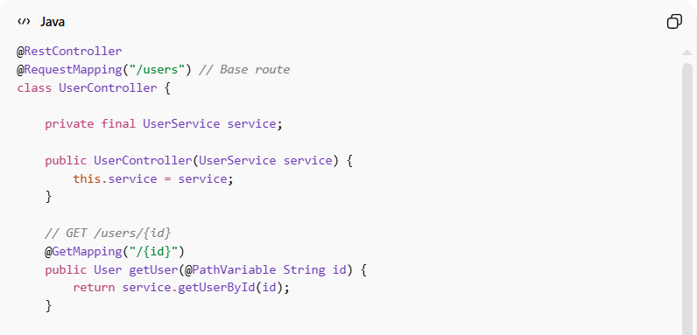
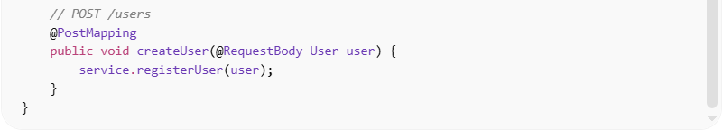
@RestController
@RequestMapping("/users") // Base route
class UserController {

private final UserService service;

public UserController(UserService service) {
this.service = service;
}

// GET /users/{id}
@GetMapping("/{id}")
public User getUser(@PathVariable String id) {
return service.getUserById(id);
}

// POST /users
@PostMapping
public void createUser(@RequestBody User user) {
service.registerUser(user);
}
}
👉 Here:
- /users/{id} → mapped to getUser()
- /users → mapped to createUser()
- The Route defines which HTTP request goes to which method

❌ Bad Example (No Clear Routing)
# Source: AI Source: Provided by: [Data Path: Persons Table -> ID Column: 1, Name_En Column: Motasem Essam] -> From: [ChatGPT] on [1/23/2026]
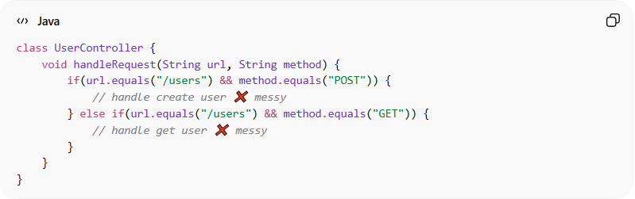
class UserController {
void handleRequest(String url, String method) {
if(url.equals("/users") && method.equals("POST")) {
// handle create user ❌ messy
} else if(url.equals("/users") && method.equals("GET")) {
// handle get user ❌ messy
}
}
}
Problems:
- Routing logic mixed inside controller
- Hard to maintain and scale
- Hard to test

✅ Good Example (Clean Routing)
# Source: AI Source: Provided by: [Data Path: Persons Table -> ID Column: 1, Name_En Column: Motasem Essam] -> From: [ChatGPT] on [1/23/2026]
- Use framework routing annotations or configurations
- Keep Controller methods focused on one action
- Apply middleware outside the controller
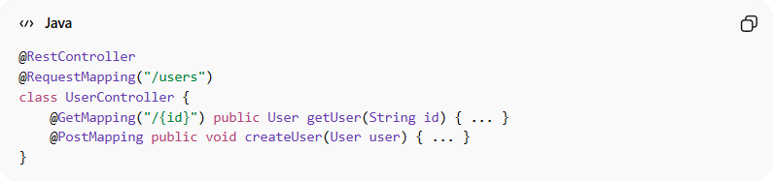
@RestController
@RequestMapping("/users")
class UserController {
@GetMapping("/{id}") public User getUser(String id) { ... }
@PostMapping public void createUser(User user) { ... }
}

🔄 Route in Different Patterns
# Source: AI Source: Provided by: [Data Path: Persons Table -> ID Column: 1, Name_En Column: Motasem Essam] -> From: [ChatGPT] on [1/23/2026]
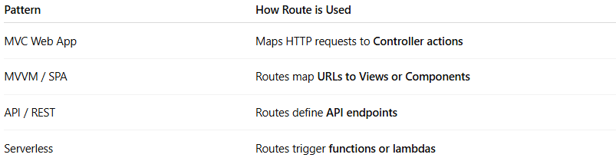
Pattern | How Route is Used
MVC Web App | Maps HTTP requests to Controller actions
MVVM / SPA | Routes map URLs to Views or Components
API / REST | Routes define API endpoints
Serverless | Routes trigger functions or lambdas

💡 Key Idea
# Source: AI Source: Provided by: [Data Path: Persons Table -> ID Column: 1, Name_En Column: Motasem Essam] -> From: [ChatGPT] on [1/23/2026]
Routes are the connection between requests and controllers. Clean routing keeps your app organized, scalable, and testable.

🧾 Summary
# Source: AI Source: Provided by: [Data Path: Persons Table -> ID Column: 1, Name_En Column: Motasem Essam] -> From: [ChatGPT] on [1/23/2026]
- Maps URLs/endpoints to Controller methods
- Defines HTTP methods and paths
- Can use middleware for auth, logging, etc.
- Keeps request handling organized and maintainable

